Experiment No. 10
Seaborn: Visualization for Categorical & Continuous Variables

Aim
- To understand Seaborn’s integration with Pandas DataFrames for statistical visu-alization.
- To create categorical visualizations: box, violin, point, line, count, bar, strip, and swarm plots.
- To create continuous-variable visualizations: scatter, regression, univariate distri-bution, joint, and pair plots.
- To use FacetGrid/catplot and heat maps for multi-panel and correlation visual-ization.

CO / PO Mapping

Course Outcome | Programme Outcomes
CO4 | PO1, PO2, PO3

Theory

Introduction to Seaborn
Seaborn is a statistical visualization library built on top of Matplotlib, designed to work directly with Pandas DataFrames. It produces attractive plots with far less code than raw Matplotlib, and includes built-in statistical aggregation (means, confidence intervals, regression fits, etc.).
import seaborn as sns import pandas as pd
import matplotlib . pyplot as plt

df = pd. Data Frame ({
" Branch ": [" CSBS", " CSBS", " EXCP ", " EXCP ", " VLSI", " VLSI"] * 5 ,
" Marks": [72 , 85 , 65 , 90 , 78 , 60] * 5
})

Categorical Plots

Plot | Description
boxplot() violinplot() pointplot()  lineplot() countplot() barplot() stripplot() swarmplot() | Shows median, quartiles, and outliers per category Box plot + kernel density shape per category  Shows the mean and confidence interval per category, connected by lines  Trend line with automatic confidence-interval shading Frequency count of each category  Mean value per category, with error bars Individual data points with slight jitter  Individual points arranged to avoid overlap
sns. boxplot( x=" Branch ", y=" Marks", data =df) plt. title (" Marks Distribution by Branch ( Box Plot)") plt. show ()

sns. violinplot( x=" Branch ", y=" Marks", data =df) plt. show ()

sns. swarmplot( x=" Branch ", y=" Marks", data =df) plt. show ()

sns. countplot( x=" Branch ", data =df) plt. title (" Number of Students per Branch ") plt. show ()

- catplot() and FacetGrid
catplot() is a figure-level function that can produce any categorical plot type (via the kind parameter) and automatically supports faceting – splitting the data into a grid of subplots based on additional categorical columns.
sns. catplot( x=" Branch ", y=" Marks", kind =" box", col=" Branch ", data
=df) plt. show ()

g = sns. FacetGrid ( df , col=" Branch ") g. map ( sns. histplot , " Marks") plt. show ()

Continuous-Variable Plots
tips_like = pd. Data Frame ({
" StudyHours": [1 , 2 , 3 , 4 , 5 , 6 , 7 , 8],
" Marks": [35 , 40 , 50 , 60 , 68 , 78 , 85 , 92]
})

# Scatter plot
sns. scatterplot( x=" StudyHours", y=" Marks", data = tips_like ) plt. show ()

# Regression plot -- scatter + fitted line + confidence band sns. regplot( x=" StudyHours", y=" Marks", data = tips_like ) plt. title (" Study Hours vs Marks with Regression Line ") plt. show ()

# Univariate distribution sns. histplot( tips_like [" Marks"], kde= True ) plt. title (" Distribution of Marks") plt. show ()

Joint and Pair Plots
# Joint plot: scatter + marginal histograms for two variables sns. jointplot( x=" StudyHours", y=" Marks", data = tips_like , kind ="
scatter") plt. show ()

# Joint hexbin plot: useful for dense / large datasets sns. jointplot( x=" StudyHours", y=" Marks", data = tips_like , kind ="
hex") plt. show ()

# Pair plot: scatter matrix for every pair of numeric columns sns. pairplot( df_numeric) # df_numeric = a Data Frame with
several numeric columns plt. show ()

Heat Map
A heat map displays matrix-like data (e.g. a correlation matrix) using color intensity to represent magnitude.

corr_matrix = tips_like . corr ()

sns. heatmap ( corr_matrix , annot=True , cmap =" coolwarm ") plt. title (" Correlation Heat Map ")
plt. show ()

Laboratory Tasks
(Every chart must include a title and, where the dataset has multiple categories, appro-priate axis/category labels.)

Datasets Used in This Experiment
The Laboratory Tasks in this experiment use real, publicly available, standard datasets (loaded directly from CSV using pd.readcsv(url)) instead of synthetic data, so that the resulting charts carry genuine, meaningful patterns.
Dataset | Source Link | Used In
Penguins (species  measurements) | https://raw.githubusercontent.com/  mwaskom/seaborn-data/master/penguins.csv | Task 1
Diamonds (gemstone  attributes & price) | https://raw.githubusercontent.com/  mwaskom/seaborn-data/master/diamonds.csv | Task 2
Iris (flower measure-  ments) | https://raw.githubusercontent.com/  mwaskom/seaborn-data/master/iris.csv | Task 3

Note: All three are part of the well-known seaborn sample-data collection (Palmer Station penguins, the classic diamonds pricing dataset, and Fisher’s Iris dataset) and can be loaded directly with pd.readcsv() – no login or download step is required.

Task 1: Categorical Comparison Dashboard
Dataset: Penguins (see Datasets Used in This Experiment above; 344 penguin records covering species, island, bill length/depth, flipper length, body mass, and sex). Write a Python program that loads the Penguins dataset and, in a single figure with subplots, displays:
- A boxplot and a violinplot of bodymassg by species, placed side by side for direct comparison.
- A swarmplot overlaid on top of a boxplot (same axes) of flipperlengthmm by species, to show individual data points along with the summary statistics.

- A countplot showing how many penguins of each species were recorded on each island (hue="island").
import os
import pandas as pd
import matplotlib.pyplot as plt
import seaborn as sns

SCRIPT_DIR = os.path.dirname(os.path.abspath(__file__))
PENGUINS_URL = "https://raw.githubusercontent.com/mwaskom/seaborn-data/master/penguins.csv"

def load_penguins():
local_path = os.path.join(os.path.dirname(os.path.abspath(__file__)), "penguins.csv")
if os.path.exists(local_path):
return pd.read_csv(local_path)
return pd.read_csv(PENGUINS_URL)

def main():
df = load_penguins()
print(f"Loaded Penguins dataset: {df.shape[0]} rows x {df.shape[1]} columns")
df = df.dropna(subset=["species", "body_mass_g", "flipper_length_mm", "island"])

fig, axes = plt.subplots(2, 2, figsize=(14, 10))
fig.suptitle("Task 1: Categorical Comparison Dashboard - Penguins Dataset",
fontsize=15, fontweight="bold")

sns.boxplot(x="species", y="body_mass_g", data=df, ax=axes[0, 0],
hue="species", palette="pastel")
axes[0, 0].set_title("Boxplot: Body Mass (g) by Species")
axes[0, 0].set_xlabel("Species")
axes[0, 0].set_ylabel("Body Mass (g)")

sns.violinplot(x="species", y="body_mass_g", data=df, ax=axes[0, 1],
hue="species", palette="muted")
axes[0, 1].set_title("Violinplot: Body Mass (g) by Species")
axes[0, 1].set_xlabel("Species")
axes[0, 1].set_ylabel("Body Mass (g)")

sns.boxplot(x="species", y="flipper_length_mm", data=df, ax=axes[1, 0],
hue="species", palette="Set2", showfliers=False)
sns.swarmplot(x="species", y="flipper_length_mm", data=df, ax=axes[1, 0],
color="black", size=4, alpha=0.8)
axes[1, 0].set_title("Swarmplot over Boxplot: Flipper Length (mm) by Species")
axes[1, 0].set_xlabel("Species")
axes[1, 0].set_ylabel("Flipper Length (mm)")

sns.countplot(x="species", hue="island", data=df, ax=axes[1, 1],
palette="Set1")
axes[1, 1].set_title("Countplot: Penguin Species Count per Island")
axes[1, 1].set_xlabel("Species")
axes[1, 1].set_ylabel("Number of Penguins")
axes[1, 1].legend(title="Island")

plt.tight_layout(rect=[0, 0, 1, 0.96])
plt.savefig(os.path.join(SCRIPT_DIR, "ex10_task1_categorical_dashboard.png"), dpi=150, bbox_inches="tight")
plt.show()

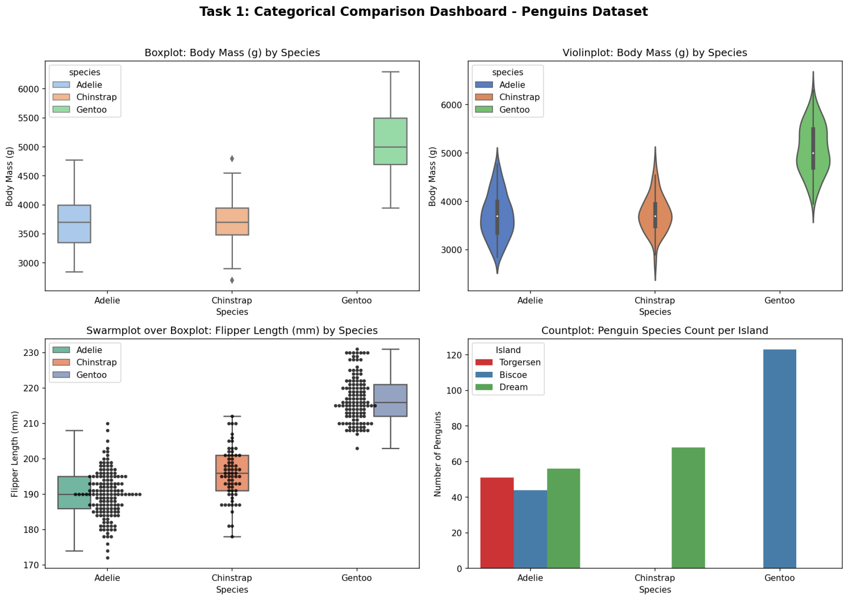

Task 2: Continuous Relationship and Distribution Analysis
Dataset: Diamonds (see Datasets Used in This Experiment above; nearly 54,000 records; relevant columns: carat, price, cut). Since the full dataset is large, take a random sample of about 500 rows (df.sample(500, randomstate=1)) for readable plots.
Write a Python program that:
- Creates a regplot of carat vs. price to visualize the relationship with a fitted regression line and confidence band.
- Creates a jointplot (kind="hex") on the full, unsampled dataset for carat vs. price, taking advantage of hexbin’s ability to summarize dense data that a plain scatter plot would over-plot.
- Comments (in code comments) on whether the carat–price relationship appears linear or curved, based on the regression plot.
import os
import pandas as pd
import matplotlib.pyplot as plt
import seaborn as sns

SCRIPT_DIR = os.path.dirname(os.path.abspath(__file__))
DIAMONDS_URL = "https://raw.githubusercontent.com/mwaskom/seaborn-data/master/diamonds.csv"

def load_diamonds():
local_path = os.path.join(os.path.dirname(os.path.abspath(__file__)), "diamonds.csv")
if os.path.exists(local_path):
return pd.read_csv(local_path)
return pd.read_csv(DIAMONDS_URL)

def main():
df = load_diamonds()
print(f"Loaded Diamonds dataset: {df.shape[0]} rows x {df.shape[1]} columns")

sample_df = df.sample(500, random_state=1)

plt.figure(figsize=(8, 6))
sns.regplot(x="carat", y="price", data=sample_df,
scatter_kws={"alpha": 0.5, "s": 25, "color": "steelblue"},
line_kws={"color": "red"})
plt.title("Diamonds: Carat vs Price with Regression Line (Sample of 500)")
plt.xlabel("Carat (weight of diamond)")
plt.ylabel("Price (USD)")
plt.tight_layout()
plt.savefig(os.path.join(SCRIPT_DIR, "ex10_task2_carat_vs_price_regplot.png"), dpi=150, bbox_inches="tight")
plt.show()

g = sns.jointplot(x="carat", y="price", data=df, kind="hex",
height=8, color="teal", joint_kws={"gridsize": 40})
g.fig.suptitle("Diamonds: Carat vs Price Hexbin Joint Plot (Full Dataset)",
y=1.02, fontsize=13, fontweight="bold")
g.set_axis_labels("Carat", "Price (USD)")
g.savefig(os.path.join(SCRIPT_DIR, "ex10_task2_carat_vs_price_hexbin.png"), dpi=150, bbox_inches="tight")
plt.show()

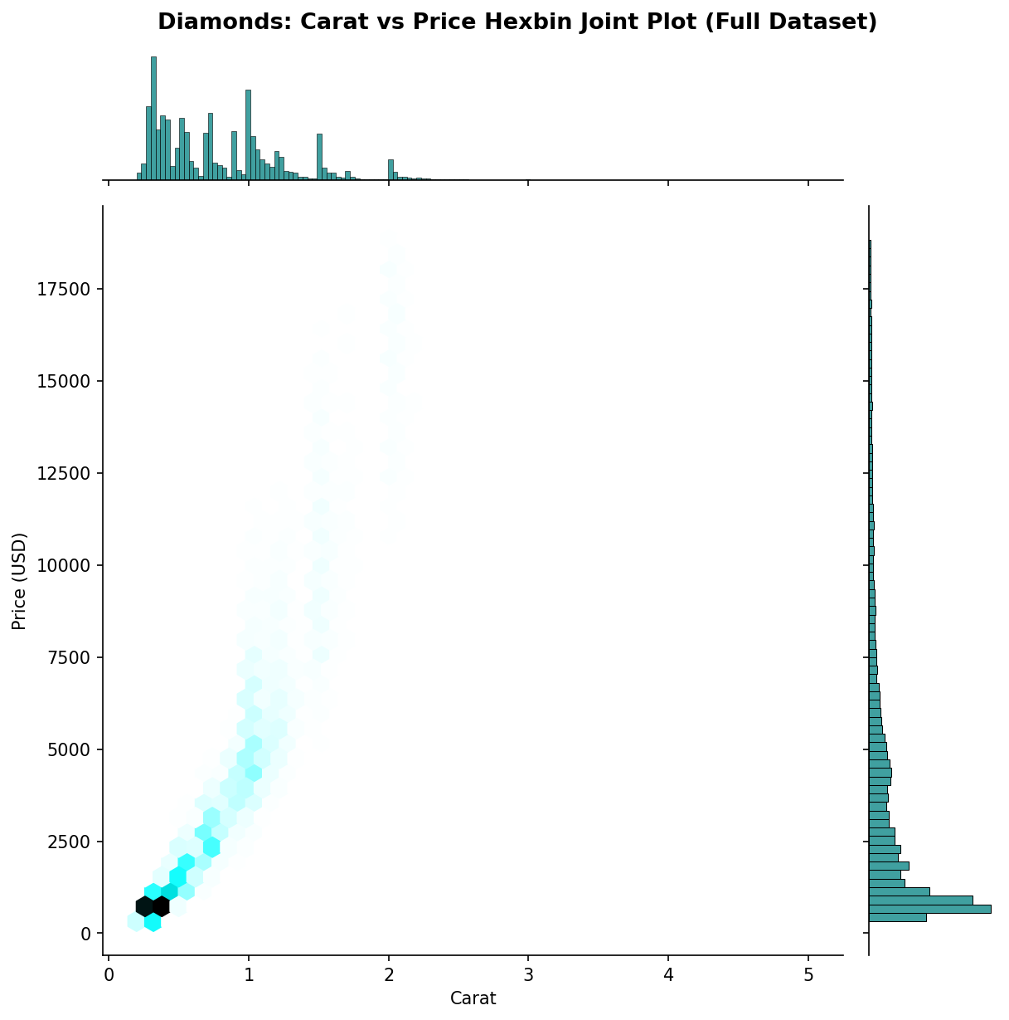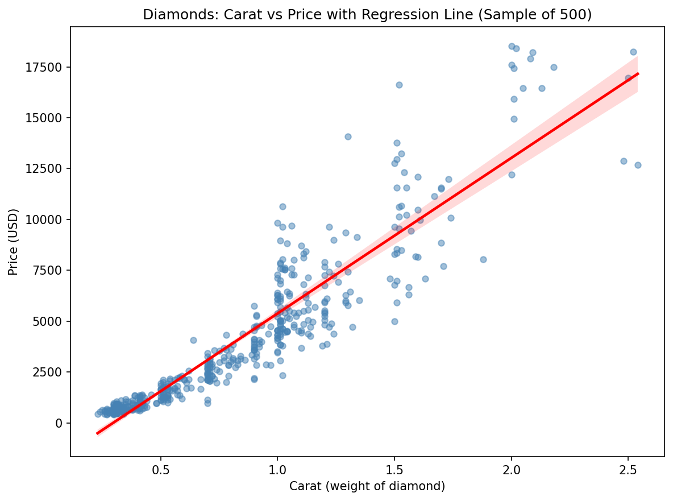

Task 3: Multi-Variable Exploration with Pair Plot and Heat Map
Dataset: Iris (see Datasets Used in This Experiment above; 150 records; columns:
sepallength, sepalwidth, petallength, petalwidth, species).
Write a Python program that:
- Generates a pairplot of all four numeric columns, colored by species using the hue parameter, to visually explore relationships between every pair of measurements at once.
- Computes the correlation matrix of the four numeric columns and visualizes it with an annotated heatmap.
- Identifies, from the heat map, the pair of measurements with the strongest correla-tion, and prints that pair along with its correlation value.
import os
import pandas as pd
import matplotlib.pyplot as plt
import seaborn as sns

SCRIPT_DIR = os.path.dirname(os.path.abspath(__file__))
IRIS_URL = "https://raw.githubusercontent.com/mwaskom/seaborn-data/master/iris.csv"

def load_iris():
local_path = os.path.join(os.path.dirname(os.path.abspath(__file__)), "iris.csv")
if os.path.exists(local_path):
return pd.read_csv(local_path)
return pd.read_csv(IRIS_URL)

def main():
df = load_iris()
print(f"Loaded Iris dataset: {df.shape[0]} rows x {df.shape[1]} columns")
print(f"Columns: {list(df.columns)}")

numeric_cols = ["sepal_length", "sepal_width", "petal_length", "petal_width"]

g = sns.pairplot(df, vars=numeric_cols, hue="species",
palette="bright", diag_kind="kde",
plot_kws={"alpha": 0.7, "s": 25})
g.fig.suptitle("Task 3: Iris Pairplot Coloured by Species",
y=1.02, fontsize=14, fontweight="bold")
g.savefig(os.path.join(SCRIPT_DIR, "ex10_task3_iris_pairplot.png"), dpi=150, bbox_inches="tight")
plt.show()

corr_matrix = df[numeric_cols].corr()
print("\nCorrelation Matrix:")
print(corr_matrix.round(3))

plt.figure(figsize=(7, 6))
sns.heatmap(corr_matrix, annot=True, fmt=".2f", cmap="coolwarm",
vmin=-1, vmax=1, square=True, linewidths=0.5)
plt.title("Iris: Correlation Heat Map of Numerical Features")
plt.tight_layout()
plt.savefig(os.path.join(SCRIPT_DIR, "ex10_task3_iris_heatmap.png"), dpi=150, bbox_inches="tight")
plt.show()

stacked = corr_matrix.unstack()
strongest = stacked[stacked.index.get_level_values(0) !=
stacked.index.get_level_values(1)].idxmax()

print("\n--- Strongest Correlation ---")
print(f"Pair of measurements : {strongest[0]} <-> {strongest[1]}")
print(f"Correlation value : {stacked[strongest]:.3f}")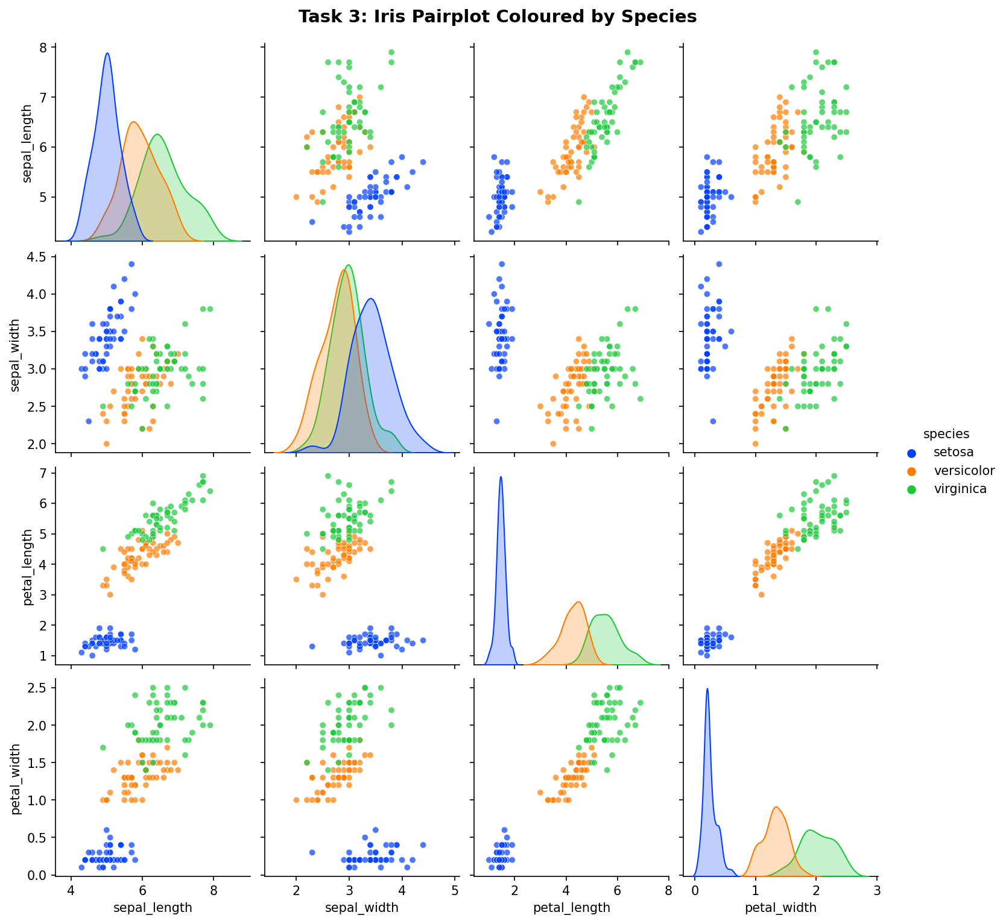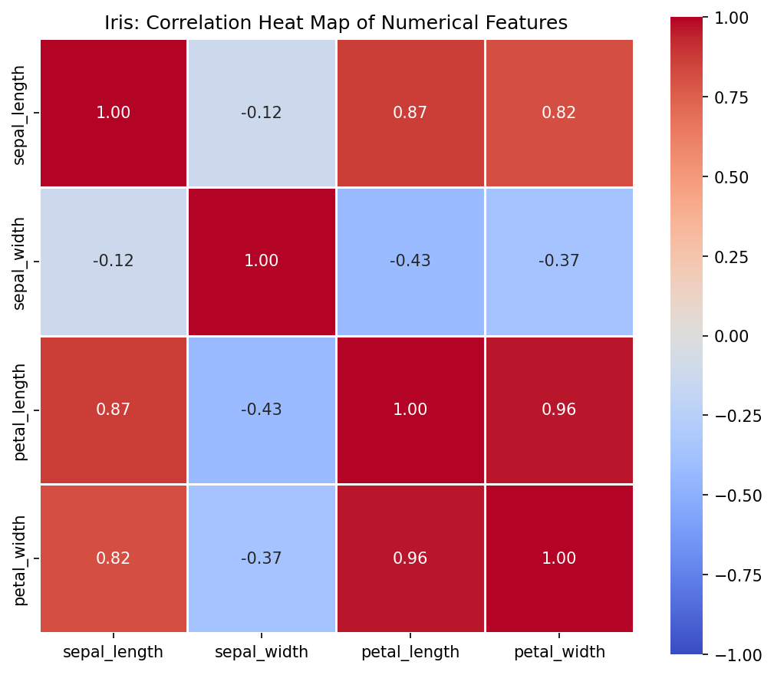

AI Case Study: Patient Test-Result Visualization us-ing Seaborn

Problem Statement
A point-of-care screening system collects glucose readings from repeated urine-strip tests across different wards of a hospital over a monitoring period. The collected data must be

analysed and visualised to understand glucose variation over time and identify ward sec-tions experiencing higher abnormality. Using the Python Seaborn library, create mean-ingful statistical visualisations for the given healthcare dataset.

Objectives
- Understand the use of Seaborn for statistical data visualization.
- Visualise the variation of glucose readings during different monitoring phases.
- Represent ward-wise abnormality values using a heat map.
- Add suitable labels, titles, legends, and annotations.
- Interpret the visualisations and identify ward sections requiring attention.

Given Dataset
Consider the following glucose readings recorded from a sample patient:

Monitoring Day | Phase | Glucose Reading (mg/dL)
0 | Baseline | 108
3 | Baseline | 122
6 | Rising | 138
9 | Rising | 151
12 | Peak | 166
15 | Peak | 182
18 | Peak | 158
21 | Recovery | 144
24 | Recovery | 128
The following abnormality index values are recorded for different hospital wards:

 | S1 | S2 | S3 | S4 | S5
Ward A | 22 | 35 | 48 | 61 | 30
Ward B | 28 | 42 | 55 | 67 | 36
Ward C | 18 | 31 | 51 | 73 | 44
Ward D | 32 | 46 | 63 | 69 | 41

Glucose-Abnormality Classification
Use the following interpretation for the abnormality index:

- AI < 30 : Low Abnormality

- 30 ≤ AI < 50 : Moderate Abnormality
- 50 ≤ AI < 70 : High Abnormality
- AI ≥ 70 : Severe Abnormality

Tasks
- Import the required libraries:
  - seaborn
  - matplotlib.pyplot
  - pandas
- Create a Pandas DataFrame containing the patient glucose-monitoring data.
- Use Seaborn to create a line plot showing the change in glucose reading with mon-itoring day.
- Differentiate the monitoring phases in the visualisation using suitable Seaborn plot-ting options.
- Add a horizontal reference line at the critical glucose level of 140 mg/dL.
- Identify the monitoring day at which the glucose reading reaches its maximum value and highlight this point on the graph.
- Create a separate DataFrame for the ward-wise abnormality values.
- Use seaborn.heatmap() to generate a heat map representing abnormality across the wards.
- Display the numerical AI values inside the heat-map cells.
- Add appropriate axis labels, title, and colour scale to the heat map.
- Determine:
  - The ward section with the highest abnormality value.
  - The corresponding ward/section combination.
  - The maximum AI value.
  - The number of cells having AI ≥ 70.
- Based on the visualisations, identify whether the patient requires clinical attention during the later phases of the monitoring period.

Expected Interpretation
From the glucose visualisation, determine the period during which the patient experiences the highest glucose level.
From the heat map, identify ward sections with:
  - Low abnormality,
  - Moderate abnormality,
  - High abnormality, and
  - Severe abnormality.
The visualisation should make it easy for a clinical decision-maker to identify areas that may require priority attention.

Additional Questions
- Modify the line plot to display the glucose reading and another parameter such as protein reading for the same monitoring period.
- Change the Seaborn line-plot marker and line style to improve readability.
- Use a different Seaborn colour palette for the heat map and observe its effect on interpretation.
- Create a heat map using only the ward sections where AI is greater than or equal to 50.
- Calculate the average AI for each ward and identify the ward having the highest average abnormality.
- Create a box plot using Seaborn to compare the distribution of glucose values across different monitoring phases.
- Add a suitable threshold indicator to the glucose visualisation and identify all read-ings above the threshold.
- Save both visualisations as image files using Matplotlib’s savefig() function.
- Modify the program so that the glucose and abnormality data can be read from CSV files instead of being hard-coded.
- Explain the advantage of using Seaborn over directly creating the same visualisa-tions using Matplotlib.
import os
import pandas as pd
import matplotlib.pyplot as plt
import seaborn as sns

SCRIPT_DIR = os.path.dirname(os.path.abspath(__file__))

def classify_ai(value):
if value < 30:
return "Low Abnormality"
elif value < 50:
return "Moderate Abnormality"
elif value < 70:
return "High Abnormality"
else:
return "Severe Abnormality"

def main():
glucose_df = pd.DataFrame({
"Monitoring Day": [0, 3, 6, 9, 12, 15, 18, 21, 24],
"Phase": ["Baseline", "Baseline", "Rising", "Rising", "Peak",
"Peak", "Peak", "Recovery", "Recovery"],
"Glucose Reading (mg/dL)": [108, 122, 138, 151, 166, 182, 158, 144, 128],
})
print("Patient Glucose Monitoring Data:")
print(glucose_df, "\n")

plt.figure(figsize=(10, 6))
sns.lineplot(data=glucose_df,
x="Monitoring Day", y="Glucose Reading (mg/dL)",
hue="Phase", style="Phase",
markers={"Baseline": "o", "Rising": "s",
"Peak": "^", "Recovery": "D"},
dashes=False, palette="Set1", linewidth=2.5)
sns.lineplot(data=glucose_df, x="Monitoring Day",
y="Glucose Reading (mg/dL)",
color="grey", alpha=0.35, linewidth=1.2, legend=False)

plt.axhline(y=140, color="red", linestyle="--", linewidth=1.5,
label="Critical Level (140 mg/dL)")

max_row = glucose_df.loc[glucose_df["Glucose Reading (mg/dL)"].idxmax()]
plt.scatter(max_row["Monitoring Day"], max_row["Glucose Reading (mg/dL)"],
color="darkred", s=150, zorder=5, marker="*",
label=f"Maximum ({int(max_row['Monitoring Day'])} mg/dL)")
plt.annotate(f"Peak: {max_row['Glucose Reading (mg/dL)']} mg/dL "
f"on Day {int(max_row['Monitoring Day'])}",
xy=(max_row["Monitoring Day"],
max_row["Glucose Reading (mg/dL)"]),
xytext=(max_row["Monitoring Day"] - 8,
max_row["Glucose Reading (mg/dL)"] + 6),
arrowprops=dict(arrowstyle="->", color="darkred"))

plt.title("Patient Glucose Variation Across Monitoring Phases")
plt.xlabel("Monitoring Day")
plt.ylabel("Glucose Reading (mg/dL)")
plt.legend(title="Phase", loc="lower right", fontsize=9)
plt.grid(alpha=0.3)
plt.tight_layout()
plt.savefig(os.path.join(SCRIPT_DIR, "ex10_ai_glucose_variation.png"), dpi=150, bbox_inches="tight")
plt.show()

abnormality_df = pd.DataFrame(
[[22, 35, 48, 61, 30],
[28, 42, 55, 67, 36],
[18, 31, 51, 73, 44],
[32, 46, 63, 69, 41]],
index=["Ward A", "Ward B", "Ward C", "Ward D"],
columns=["S1", "S2", "S3", "S4", "S5"])
abnormality_df.index.name = "Ward"
abnormality_df.columns.name = "Section"
print("\nWard-wise Abnormality Index:")
print(abnormality_df, "\n")

plt.figure(figsize=(9, 6))
sns.heatmap(abnormality_df, annot=True, fmt="d", cmap="YlOrRd",
linewidths=0.5, linecolor="white",
cbar_kws={"label": "Abnormality Index (AI)"})
plt.title("Ward-wise Abnormality Index Heat Map")
plt.xlabel("Hospital Section")
plt.ylabel("Ward")
plt.tight_layout()
plt.savefig(os.path.join(SCRIPT_DIR, "ex10_ai_ward_heatmap.png"), dpi=150, bbox_inches="tight")
plt.show()

max_cell = abnormality_df.stack().idxmax()
max_value = abnormality_df.stack().max()
severe_cells = abnormality_df[abnormality_df >= 70].stack()

print("\n--- Heat Map Analysis ---")
print(f"Ward/Section with highest abnormality : {max_cell[0]} / {max_cell[1]}")
print(f"Maximum AI value : {max_value}")
print(f"Number of cells with AI >= 70 : {len(severe_cells)}")
for (ward, section), value in severe_cells.items():
print(f" {ward} / {section} -> AI = {value} ({classify_ai(value)})")

print("\nCell-by-cell classification:")
for (ward, section), value in abnormality_df.stack().items():
print(f" {ward} / {section} -> AI = {value:2d} : {classify_ai(value)}")

print("\n--- Interpretation ---")
print("Glucose: the reading rises from the Baseline phase and peaks at")
print(f"{max_row['Glucose Reading (mg/dL)']} mg/dL on Day "
f"{int(max_row['Monitoring Day'])} (Peak phase). It stays above the")
print("140 mg/dL critical line from Day 9 through Day 21. YES - the patient")
print("requires clinical attention during the later (Peak and early")
print("Recovery) phases, since readings remain critically high.")
print("Heat map: Section S4 of every ward is High/Severe, with Ward C / S4")
print("(AI = 73) the single worst cell - it needs priority attention.")
print("Ward B / S4 and Ward D / S4 (AI = 67, 69) are close behind.")

if __name__ == "__main__":
main()
import os
import pandas as pd
import matplotlib.pyplot as plt
import seaborn as sns

SCRIPT_DIR = os.path.dirname(os.path.abspath(__file__))

def load_data_from_csv():
glucose_csv = os.path.join(SCRIPT_DIR, "glucose_readings.csv")
abnormality_csv = os.path.join(SCRIPT_DIR, "ward_abnormality.csv")

if not os.path.exists(glucose_csv):
pd.DataFrame({
"Monitoring Day": [0, 3, 6, 9, 12, 15, 18, 21, 24],
"Phase": ["Baseline", "Baseline", "Rising", "Rising", "Peak",
"Peak", "Peak", "Recovery", "Recovery"],
"Glucose Reading (mg/dL)": [108, 122, 138, 151, 166, 182, 158, 144, 128],
"Protein Reading (mg/dL)": [12, 14, 18, 24, 30, 34, 26, 20, 15],
}).to_csv(glucose_csv, index=False)
print(f"Created {glucose_csv}")

if not os.path.exists(abnormality_csv):
pd.DataFrame(
[[22, 35, 48, 61, 30],
[28, 42, 55, 67, 36],
[18, 31, 51, 73, 44],
[32, 46, 63, 69, 41]],
index=["Ward A", "Ward B", "Ward C", "Ward D"],
columns=["S1", "S2", "S3", "S4", "S5"]).to_csv(abnormality_csv)
print(f"Created {abnormality_csv}")

glucose_df = pd.read_csv(glucose_csv)
abnormality_df = pd.read_csv(abnormality_csv, index_col=0)
abnormality_df.index.name = "Ward"
abnormality_df.columns.name = "Section"
return glucose_df, abnormality_df

def main():
glucose_df, abnormality_df = load_data_from_csv()
print("Glucose data loaded from CSV:")
print(glucose_df, "\n")

plt.figure(figsize=(11, 6))
sns.lineplot(data=glucose_df, x="Monitoring Day",
y="Glucose Reading (mg/dL)",
marker="o", markersize=8, linestyle="--", linewidth=2.5,
color="tab:red", label="Glucose (mg/dL)")
sns.lineplot(data=glucose_df, x="Monitoring Day",
y="Protein Reading (mg/dL)",
marker="s", markersize=8, linestyle="-.", linewidth=2.5,
color="tab:blue", label="Protein (mg/dL)")

THRESHOLD = 150
plt.axhline(y=THRESHOLD, color="green", linestyle=":", linewidth=2,
label=f"Threshold ({THRESHOLD} mg/dL)")
above = glucose_df[glucose_df["Glucose Reading (mg/dL)"] > THRESHOLD]
plt.scatter(above["Monitoring Day"], above["Glucose Reading (mg/dL)"],
color="darkgreen", s=120, zorder=5, marker="*",
label="Readings above threshold")

plt.title("Glucose and Protein Readings with Threshold Indicator")
plt.xlabel("Monitoring Day")
plt.ylabel("Reading Value")
plt.legend(fontsize=9)
plt.grid(alpha=0.3)
plt.tight_layout()
plt.savefig(os.path.join(SCRIPT_DIR, "ex10_glucose_protein_plot.png"), dpi=150, bbox_inches="tight")
print("Saved: ex10_glucose_protein_plot.png")
plt.show()

print("\nReadings above the 150 mg/dL threshold:")
print(above.to_string(index=False))

fig, axes = plt.subplots(1, 2, figsize=(15, 5.5))

sns.heatmap(abnormality_df, annot=True, fmt="d", cmap="viridis",
linewidths=0.5, ax=axes[0],
cbar_kws={"label": "Abnormality Index (AI)"})
axes[0].set_title("Heat Map with 'viridis' Palette")
axes[0].set_xlabel("Hospital Section")
axes[0].set_ylabel("Ward")

filtered = abnormality_df.where(abnormality_df >= 50)
sns.heatmap(filtered, annot=True, fmt=".0f", cmap="Reds",
linewidths=0.5, ax=axes[1],
cbar_kws={"label": "Abnormality Index (AI >= 50)"})
axes[1].set_title("Heat Map - Only Sections with AI >= 50")
axes[1].set_xlabel("Hospital Section")
axes[1].set_ylabel("Ward")

plt.tight_layout()
plt.savefig(os.path.join(SCRIPT_DIR, "ex10_ward_heatmaps.png"), dpi=150, bbox_inches="tight")
print("Saved: ex10_ward_heatmaps.png")
plt.show()

print("\nEffect of palette: 'viridis' separates mid-range values better")
print("(uniform brightness), but 'YlOrRd' communicates severity more")
print("intuitively (darker/redder = more abnormal).")

avg_by_ward = abnormality_df.mean(axis=1).round(2)
print("\nAverage AI per ward:")
print(avg_by_ward.to_string())
top_ward = avg_by_ward.idxmax()
print(f"Ward with the HIGHEST average abnormality: {top_ward} "
f"(avg AI = {avg_by_ward.max()})")

order = ["Baseline", "Rising", "Peak", "Recovery"]
plt.figure(figsize=(9, 6))
sns.boxplot(data=glucose_df, x="Phase", y="Glucose Reading (mg/dL)",
hue="Phase", palette="Set2", order=order)
sns.swarmplot(data=glucose_df, x="Phase", y="Glucose Reading (mg/dL)",
color="black", size=6, order=order)
plt.title("Glucose Distribution Across Monitoring Phases")
plt.xlabel("Monitoring Phase")
plt.ylabel("Glucose Reading (mg/dL)")
plt.tight_layout()
plt.savefig(os.path.join(SCRIPT_DIR, "ex10_additional_boxplot_swarm.png"), dpi=150, bbox_inches="tight")
plt.show()

print("\nAdvantage of Seaborn over Matplotlib:")
print("1. DataFrame-aware API: columns are referenced by name, so no")
print(" manual list extraction or index bookkeeping is needed.")
print("2. Built-in statistics: means with confidence-interval bands,")
print(" regression fits, box/violin quartiles and KDE curves are")
print(" computed automatically - Matplotlib would need NumPy/pandas")
print(" aggregation code for each of these.")
print("3. Far less code: a single sns.heatmap(...) call replaces the")
print(" imshow + colorbar + tick-label + annotation plumbing that")
print(" raw Matplotlib requires.")
print("4. Attractive defaults: colour palettes, styles and legends are")
print(" tuned for statistical graphics and are easy to switch.")
print("5. Figure-level functions (catplot, relplot, pairplot, FacetGrid)")
print(" build multi-panel, faceted charts in one line.")

if __name__ == "__main__":
main()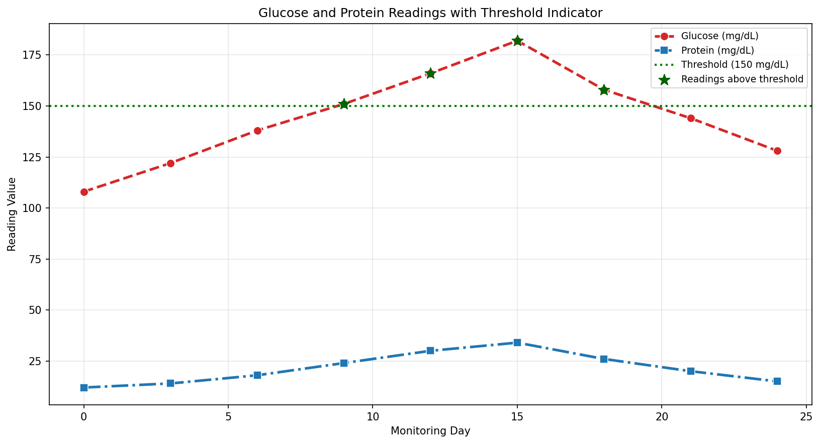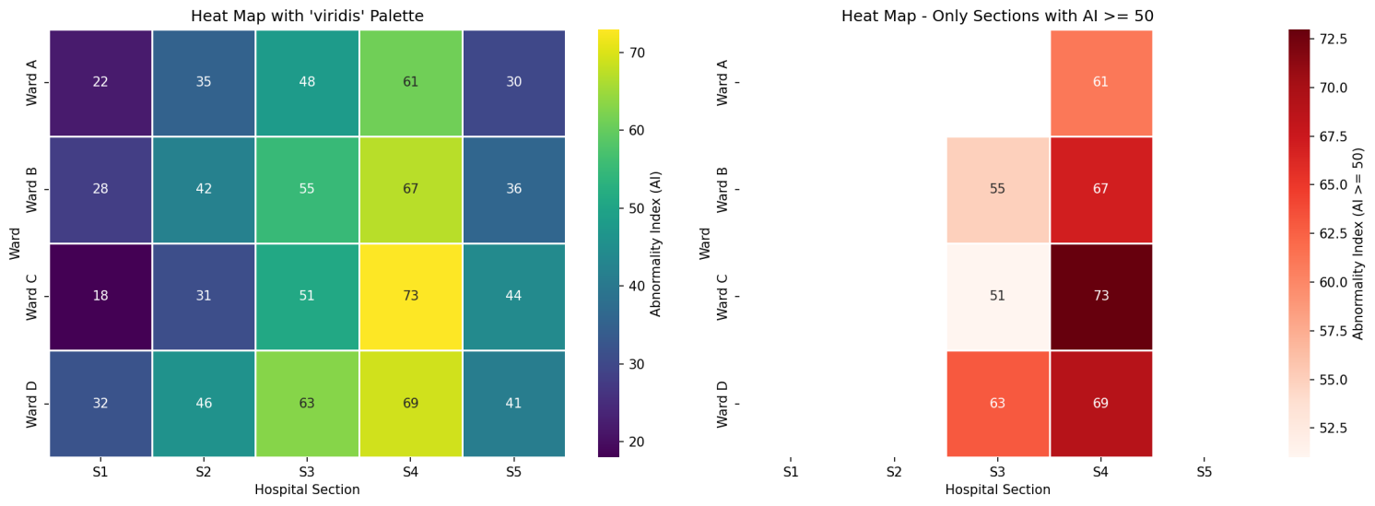

Additional Practice Tasks
- Write a program to create a stripplot and a swarmplot of exam scores grouped by study method, placed in separate subplots for comparison.
- Write a program to use sns.lineplot() with a hue parameter to plot sales trends for 3 different products over 12 months on the same chart.
- Write a program to create a FacetGrid that shows a histogram of marks separately for each branch, arranged in a grid.
- Write a program to create a pointplot comparing average marks across two cate-gorical variables simultaneously (e.g. Branch and Gender) using hue.
- Write a program to visualize a confusion-matrix-style 4×4 matrix of random integers using sns.heatmap() with integer annotations and no decimal places.
import os
import pandas as pd
import numpy as np
import matplotlib.pyplot as plt
import seaborn as sns

SCRIPT_DIR = os.path.dirname(os.path.abspath(__file__))
rng = np.random.default_rng(seed=42)

def task1_strip_swarm():
n_per_group = 25
methods = (["Self-Study"] * n_per_group +
["Coaching"] * n_per_group +
["Group Study"] * n_per_group)
scores = np.concatenate([
rng.normal(62, 10, n_per_group),
rng.normal(72, 8, n_per_group),
rng.normal(68, 9, n_per_group),
]).clip(0, 100).round()

df = pd.DataFrame({"Study Method": methods, "Exam Score": scores})

fig, axes = plt.subplots(1, 2, figsize=(13, 5.5), sharey=True)

sns.stripplot(x="Study Method", y="Exam Score", data=df,
ax=axes[0], palette="Set2", size=6, jitter=0.25,
hue="Study Method")
axes[0].set_title("Stripplot: Exam Scores by Study Method")
axes[0].set_xlabel("Study Method")
axes[0].set_ylabel("Exam Score")

sns.swarmplot(x="Study Method", y="Exam Score", data=df,
ax=axes[1], palette="Set1", size=6,
hue="Study Method")
axes[1].set_title("Swarmplot: Exam Scores by Study Method")
axes[1].set_xlabel("Study Method")
axes[1].set_ylabel("Exam Score")

plt.tight_layout()
plt.savefig(os.path.join(SCRIPT_DIR, "ex10_practice_task1_strip_swarm.png"), dpi=150, bbox_inches="tight")
plt.show()

def task2_lineplot_hue():
months = list(range(1, 13))
product_a = [120, 132, 125, 140, 150, 162, 158, 170, 180, 175, 190, 205]
product_b = [90, 85, 95, 88, 102, 98, 110, 115, 108, 120, 118, 128]
product_c = [60, 70, 65, 80, 78, 90, 95, 92, 105, 100, 112, 120]

df = pd.DataFrame({
"Month": months * 3,
"Sales": product_a + product_b + product_c,
"Product": ["Product A"] * 12 + ["Product B"] * 12 + ["Product C"] * 12,
})

plt.figure(figsize=(10, 6))
sns.lineplot(data=df, x="Month", y="Sales", hue="Product",
marker="o", linewidth=2.5, palette="bright")
plt.title("Monthly Sales Trends of Three Products")
plt.xlabel("Month (1-12)")
plt.ylabel("Units Sold")
plt.xticks(months)
plt.legend(title="Product")
plt.grid(alpha=0.3)
plt.tight_layout()
plt.savefig(os.path.join(SCRIPT_DIR, "ex10_practice_task2_lineplot.png"), dpi=150, bbox_inches="tight")
plt.show()

def task3_facetgrid_hist():
branches = ["CSBS", "EXCP", "VLSI"] * 30
marks = np.concatenate([
rng.normal(72, 8, 30),
rng.normal(65, 10, 30),
rng.normal(78, 6, 30),
]).clip(0, 100).round()

df = pd.DataFrame({"Branch": branches, "Marks": marks})

g = sns.FacetGrid(df, col="Branch", col_wrap=3, height=4)
g.map(sns.histplot, "Marks", bins=10, kde=True, color="steelblue")
g.set_axis_labels("Marks", "Number of Students")
g.set_titles(col_template="{col_name} Branch")
g.figure.suptitle("Distribution of Marks by Branch (FacetGrid)",
y=1.05, fontsize=13, fontweight="bold")
g.savefig(os.path.join(SCRIPT_DIR, "ex10_practice_task3_facetgrid_hist.png"), dpi=150, bbox_inches="tight")
plt.show()

def task4_pointplot_hue():
data_rows = []
for branch, base in [("CSBS", 72), ("EXCP", 65), ("VLSI", 78)]:
for gender, shift in [("Male", -3), ("Female", 3)]:
scores = rng.normal(base + shift, 6, 25).clip(0, 100).round()
data_rows += [{"Branch": branch, "Gender": gender, "Marks": m}
for m in scores]

df = pd.DataFrame(data_rows)

plt.figure(figsize=(9, 6))
sns.pointplot(data=df, x="Branch", y="Marks", hue="Gender",
palette="deep", capsize=0.1,
markers=["o", "s"], linestyles=["-", "--"], errorbar=None)
plt.title("Average Marks by Branch and Gender (Point Plot)")
plt.xlabel("Branch")
plt.ylabel("Average Marks")
plt.legend(title="Gender")
plt.grid(alpha=0.3)
plt.tight_layout()
plt.savefig(os.path.join(SCRIPT_DIR, "ex10_practice_task4_pointplot.png"), dpi=150, bbox_inches="tight")
plt.show()

avg = df.groupby(["Branch", "Gender"])["Marks"].mean().round(2)
print("Average marks by Branch and Gender:")
print(avg)

def task5_confusion_heatmap():
matrix = rng.integers(low=5, high=60, size=(4, 4))

classes = ["Class 0", "Class 1", "Class 2", "Class 3"]
plt.figure(figsize=(7, 6))
sns.heatmap(matrix, annot=True, fmt="d", cmap="Blues",
linewidths=0.5, linecolor="white",
xticklabels=classes, yticklabels=classes,
cbar_kws={"label": "Count"})
plt.title("4x4 Confusion-Matrix-Style Heat Map (Integer Annotations)")
plt.xlabel("Predicted Class")
plt.ylabel("Actual Class")
plt.tight_layout()
plt.savefig(os.path.join(SCRIPT_DIR, "ex10_practice_task5_confusion_heatmap.png"), dpi=150, bbox_inches="tight")
plt.show()

print("Matrix used:")
print(matrix)

if __name__ == "__main__":
print("=" * 60)
print("Practice Task 1: Stripplot vs Swarmplot")
print("=" * 60)
task1_strip_swarm()

print("\n" + "=" * 60)
print("Practice Task 2: Sales Line Plot with hue")
print("=" * 60)
task2_lineplot_hue()

print("\n" + "=" * 60)
print("Practice Task 3: FacetGrid Histograms")
print("=" * 60)
task3_facetgrid_hist()

print("\n" + "=" * 60)
print("Practice Task 4: Point Plot with Two Categories")
print("=" * 60)
task4_pointplot_hue()

print("\n" + "=" * 60)
print("Practice Task 5: 4x4 Confusion-Style Heat Map")
print("=" * 60)
task5_confusion_heatmap()

Post-Lab Questions

Conceptual Questions
- What is the key advantage of Seaborn over raw Matplotlib when working with Pandas DataFrames?
- Differentiate between a stripplot and a swarmplot. Why might one be preferred over the other for a large dataset?
- What is the difference between an axes-level function (e.g. sns.boxplot) and a figure-level function (e.g. sns.catplot) in Seaborn?
- What does the shaded band around a line in sns.lineplot() or sns.regplot() represent?
- What is the purpose of the hue parameter, and how does it extend a 2-D plot to represent a third categorical dimension?

Application-Based Questions
- In Task 3, why is a pairplot with hue more informative than plotting each pair of variables separately without color grouping?
- In Task 4, why is a diverging colormap (e.g. "coolwarm") more appropriate than a single-hue colormap for visualizing severity levels?
- When would a jointplot with kind="hex" be preferred over kind="scatter"?

Learning Outcome
After completing this experiment, students will be able to:
  - Create categorical visualizations (box, violin, point, line, count, bar, strip, swarm) using Seaborn.
  - Create continuous-variable visualizations (scatter, regression, distribution, joint, pair plots).
  - Use FacetGrid/catplot to build multi-panel comparative visualizations.
  - Visualize correlation and severity data using annotated heat maps.
  - Apply Seaborn visualization techniques to communicate patterns in AI-use-case-linked data.

